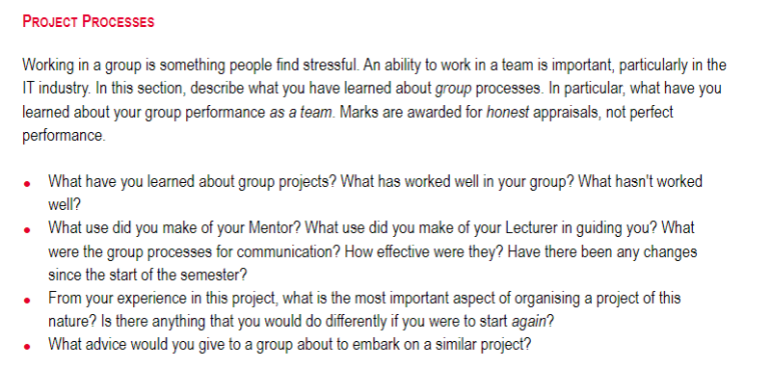

**Group Projects**

* Organise who is adept at certain skills, who would like to learn certain skills and who would not like to work on certain skills
* Allocating tasks worked well
* Discussion has worked well
* Breaking down tasks has not worked well

Our project has been a great learning experience for us. The main learning experience has been to stay organised. To know what has to be done, what is being worked on and what has been finished helps our team stay on top of the project. In terms of what worked for our group, allocating tasks to members from what needed to be done helped our productivity a lot. What we had difficulty with was breaking down tasks in terms of what is needed especially early into the project. We had many ideas individually, but it was hard to agree on things as a team.

**Mentor/Lecturer**

* Assignment specific questions
* Used teams as both discussion as well as hold formal and informal meetings
  + Been some issues but were more extenuating circumstances
  + No changes have been made in how we communicate

Our group used our mentor in order to clarify assignment related questions. Our mentor also helped guide us to resources to help with the assignments. Communication within the team happened through Microsoft Teams. We used this to discuss amongst ourselves as well as to hold both formal (recorded) meetings and informal (non-recorded) meetings. There have been some issues regarding this, but they have been mostly extenuating circumstances and as such, no changes have been made in how we communicate.

**Organising**

* Being very clear in terms of the aim of the project
* Hard to do many things differently
  + Time allocation
  + Use of members (defined roles)

The most important aspect of creating a game project is being very clear in terms of the aim and features of the project. This allows group members to be more independent in the planning and design process. If we were to do the project again, there won’t be many changes as creating game projects require very specific roles that separate the work which we were unable to do based on assignment specifications. For example, there would be set artists that create art assets, programmers that implement the game features, and designers that create the features and tone of the game (with input from others).

**Advice**

* Aim small

With a short amount of time to work on the project, make sure to stick to a small scope as creating games can cause a large amount of scope changes. It’s better to start with a smaller project and add to it then it is to create a larger project and not finish it.